Directions: The goal of the following problems is to help challenge and deepen your understanding of the current topic. Don’t assume that you will know how to answer each and every question. You will work with at least two other students in the class to try and find solutions and write arguments for each of the following questions. Be sure that you question your classmates’ reasoning. If you don’t understand how they are getting something you should ASK THEM TO EXPLAIN! Being able to defend your reasoning is important and so you are actually helping them by asking them to explain.

Challenge Questions

- The graph of g consists of two straight lines and a semi-circle. Use it to evaluate each integral.

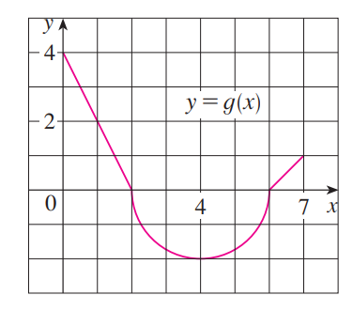

- Suppose that are continuous functions at all real numbers and that
Use properties of integrals to compute each of the following.

We know that .
Therefore,

First note that .
Therefore,

- Which of the following is true? How can you fully justify your answer without the use of a calculator?
- OR B.

We note that on the interval it is the case that and since the square root function is an increasing function is must be the case that .

Therefore, by properties of integrals (specifically property (9)) it must be the case that .

- Computing the integral is very difficult to do. Using properties of integrals to determine lower and upper bounds on the value of this integral.

We know that for all values of x it is the case that
Therefore, by property 10, it must be the case that
- Suppose that is a continuous function and the average value of on is (where a is some non-zero real number).
- Show that the area between and the x-axis on this same interval is .

- If we know that determine a non-zero value of a such that .

From part (a) we know that and now we have .
Therefore, by properties of integrals, we have

From here we see that if then .

- Show that the function must have a root on the interval .
Based on our work in part (b) we have established that when . This means that
. However, this also implies that the average value of f on is given by .

Therefore, by the Mean Value Theorem for Integrals there must exist a number c in such that .

